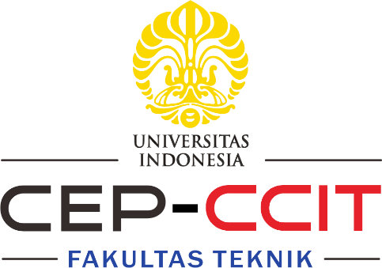

**PT Jaringan Cokro : Office and Branch Server Integration and Administration**

**Group 7**

Name : Nur Iqbal Maulana

Asia Illumina Lessy

Muhammad Armed Bintang Pradana

Class : 2CS1

Faculty : Ivan Firdaus, S.T.

CEP CCIT

FAKULTAS TEKNIK UNIVERSITAS INDONESIA

2024

**PROJECT ON**

**Developed by**

1. **Nur Iqbal Maulana**
2. **Asia Illumina Lessy**

**Muhammad Armed Bintang Pradana**



**PT Jaringan Cokro : Office and Branch Server Integration and Administration**

Batch Code : 2CS1

Start Date : 10 July 2024   
End Date : 18 July 2024

Name of Faculty : Mr. Ivan Firdaus, S.T.

Names of Developer :

1. Nur Iqbal Maulana
2. Asia Illumina Lessy
3. Muhammad Armed Bintang Pradana

Date of Submission: 18 July 2024

**CERTIFICATE**

This is to certify that this report titled “PT Jaringan Cokro : Office and Branch Server Integration and Administration” embodies the original work done by Nur Iqbal Maulana, Asia Illumina Lessy and Muhammad Armed Bintang Pradana. Project in partial fulfillment of their course requirement at NIIT.

Coordinator:

Mr. Ivan Firdaus, S.T.



**ACKNOWLEDGEMENT**

The authors would like to thank God Almighty for His blessings that enabled us to complete this project. We would also like to thank Mr. Ivan Firdaus, S.T. who always guided and helped us in completing this project.

This project discusses the implementation of Windows Server configured to integrate and to administer at PT Jaringan Cokro. Hopefully this paper can be useful to increase user knowledge on the topic. We realize that this paper still has many flaws and imperfections, and we welcome constructive criticism and suggestions from readers to help us in our efforts to improve this paper. We realize that this paper is far from perfect. Therefore, we would appreciate criticism and suggestions from the reader to help us improve this paper.

**System Analysis**

In this project, we aim to implement a 2-server network for the main server and branch servers. The system is designed to support an efficient and integrated network by utilizing several key services. One of the key services that will be implemented is two Active Directory Domain Services (AD DS), which helps to connect the main server to the branch server. Distributed File System (DFS) will be used to distribute files from the main server to several branch servers. File Server Resource Manager (FSRM) is also used in this project to manage and monitor data storage on file servers.

Other services that will be implemented include the Active Directory Rights Management Service, which will allow the main server to be the center of all management, hold access rights control and integrate with applications. For branch servers, it can distribute the workload from the main server to several branch servers and reduce the latency of the main server and branch servers.

**Services**

**System process:**

1. Active Directory

Active Directory (AD) is a Microsoft service for managing network objects like users and devices. It provides centralized authentication, authorization, and Group Policy implementation. AD's hierarchical structure simplifies management, and its scalability suits any organization size. It integrates well with Microsoft products like Exchange Server and SharePoint.

1. DFS

Distributed File System (DFS), is a set of services in Windows Server that allows administrators to organize and manage file shares across multiple servers in a network. It provides a unified namespace for users to access shared files and folders, regardless of their physical location.

1. FSRM

File Server Resource Manager (FSRM) is a suite of tools in Windows Server that allows administrators to manage and control the storage and classification of data on file servers. It provides several features to help monitor and regulate how data is stored, ensuring efficient use of storage resources and compliance with organizational policies.

1. ADRMS

Active Directory Rights Management Services (ADRMS) is a feature of the Windows Server operating system that provides information protection through persistent usage policies and rights. ADRMS helps safeguard digital information from unauthorized access and use, regardless of where it is stored or how it is shared.

**IP Table**

|  |  |  |  |  |
| --- | --- | --- | --- | --- |
| Device | IP Address | Subnet Mask | Default Gateway | DNS |
| PenguasaServer | 192.69.69.10 | 255.255.255.0 | 192.69.69.1 | 192.69.69.10 |
| JarcokBranch | 192.69.69.11 | 255.255.255.0 | 192.69.69.1 | 192.69.69.10 |

Operating system virtual machine specification :

1. Windows Server 2022 (1)

- 4GB RAM

- 50GB Storages

- 1 CPU

- 1 Internal Network Adapters

2. Windows Server 2022 (2)

- 2GB RAM

- 50GB Storages

- 1 CPU

- 1Internal Network Adapters

**Network Topology**

Internal Network Inside Virtual Box Machine

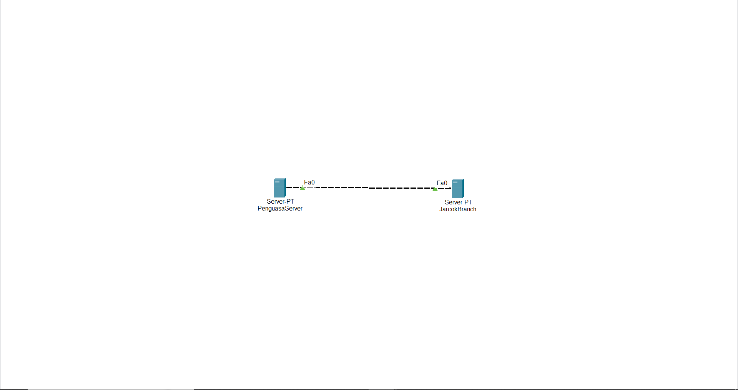

**Network Configuration**

Main Server Configuration

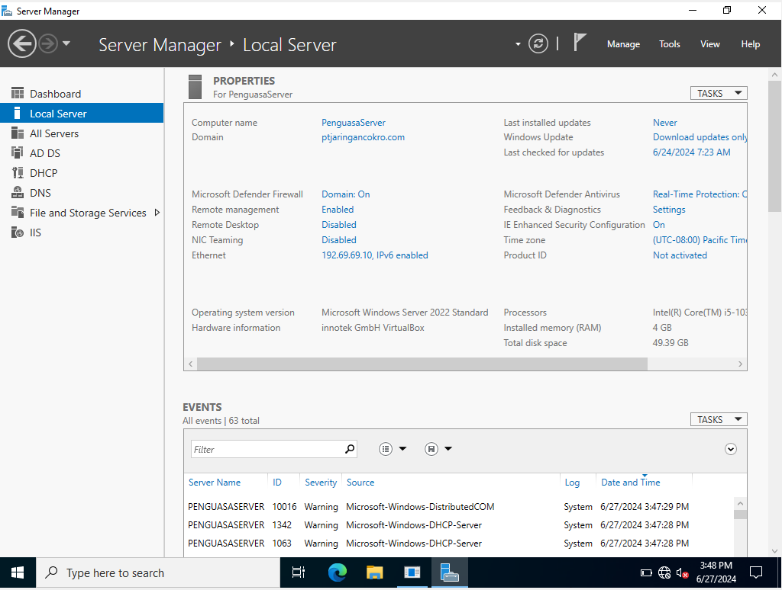

**Network Configuration**

Branch Server Configuration

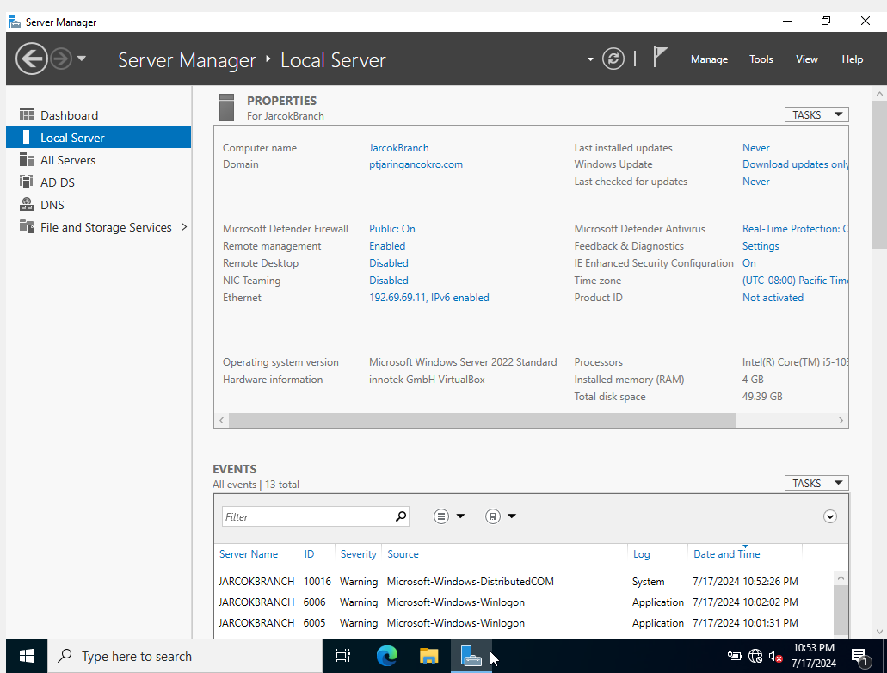

**Network Configuration**

AD Main Server and AD Branch Server Connected

Configuration

PENGUASASERVER (Main Server)

JARCOKBRANCH (Branch Server)

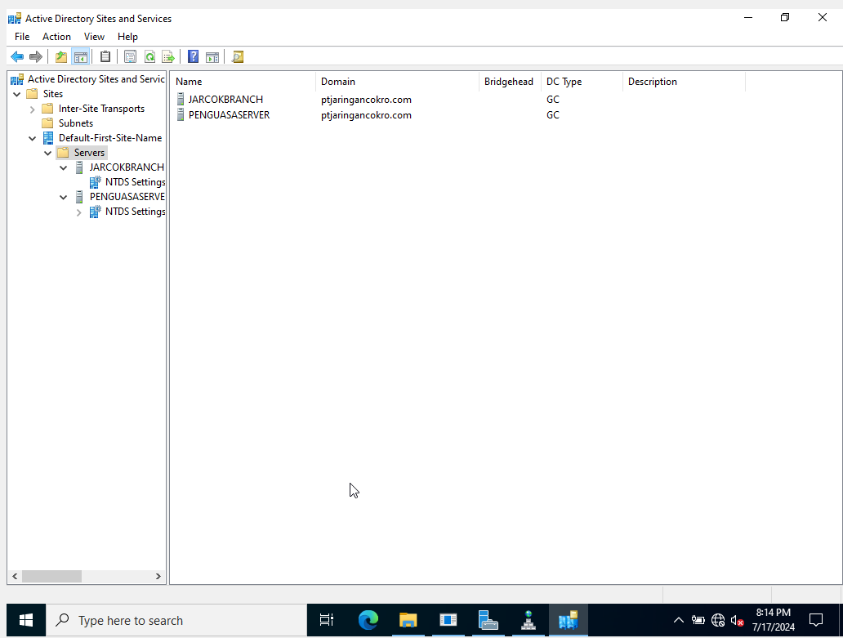

The branch server connected by adding the Domain to exsisting domain system, not add to a new forest when it was first time configurated

DFS Configuration

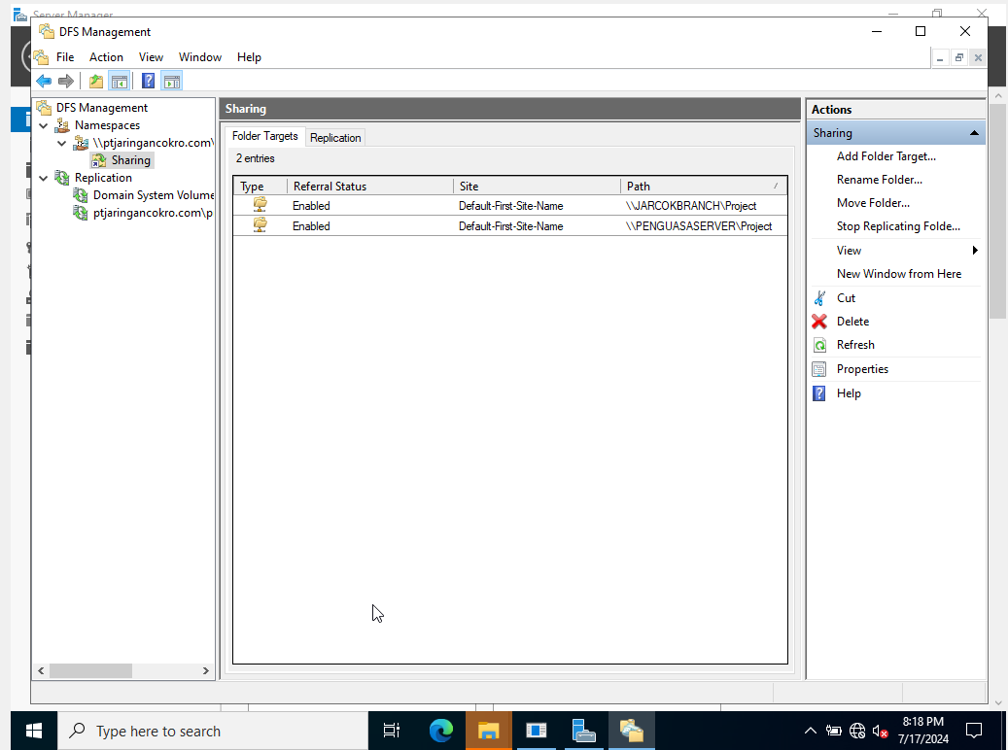

**Network Configuration**

**Network Configuration**

Quota Enabling

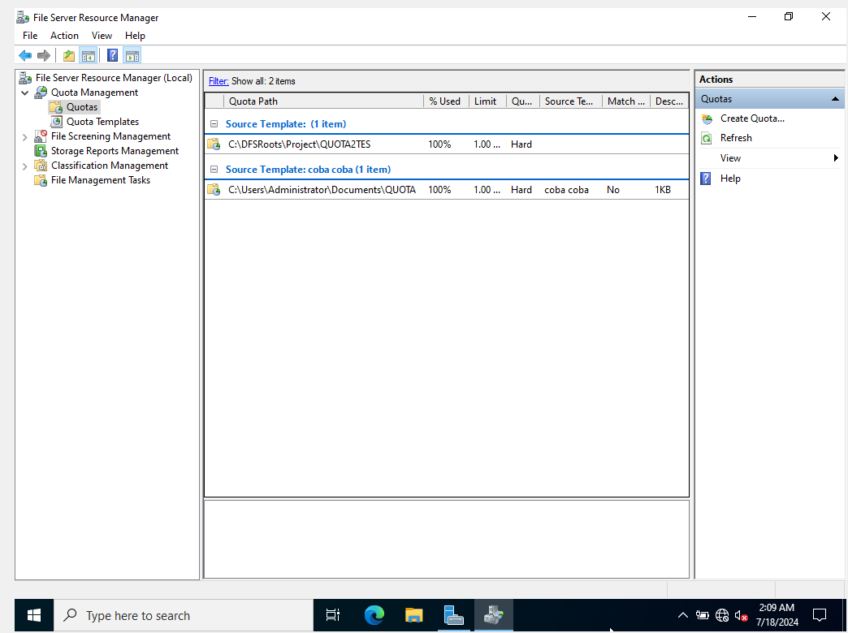

**Network Configuration**

Proof For Quota Enabling

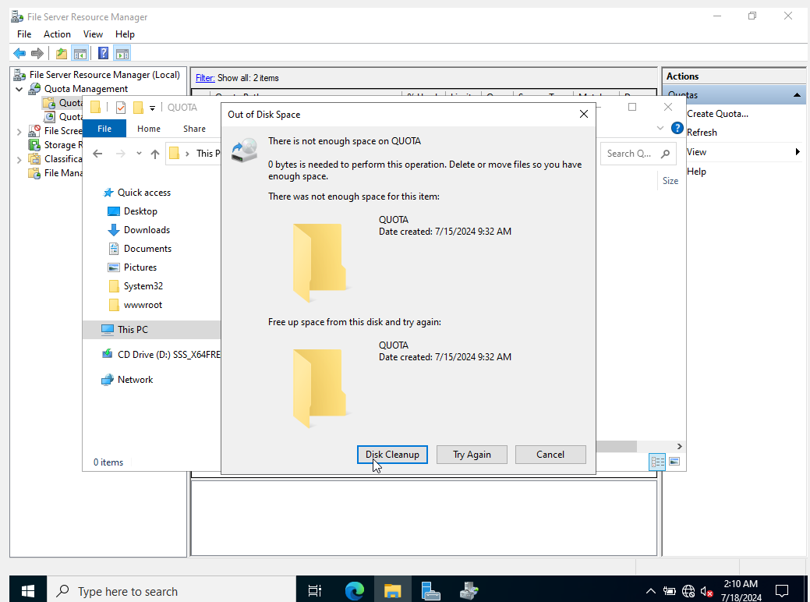

**Network Configuration**

Interactive Quota Report :

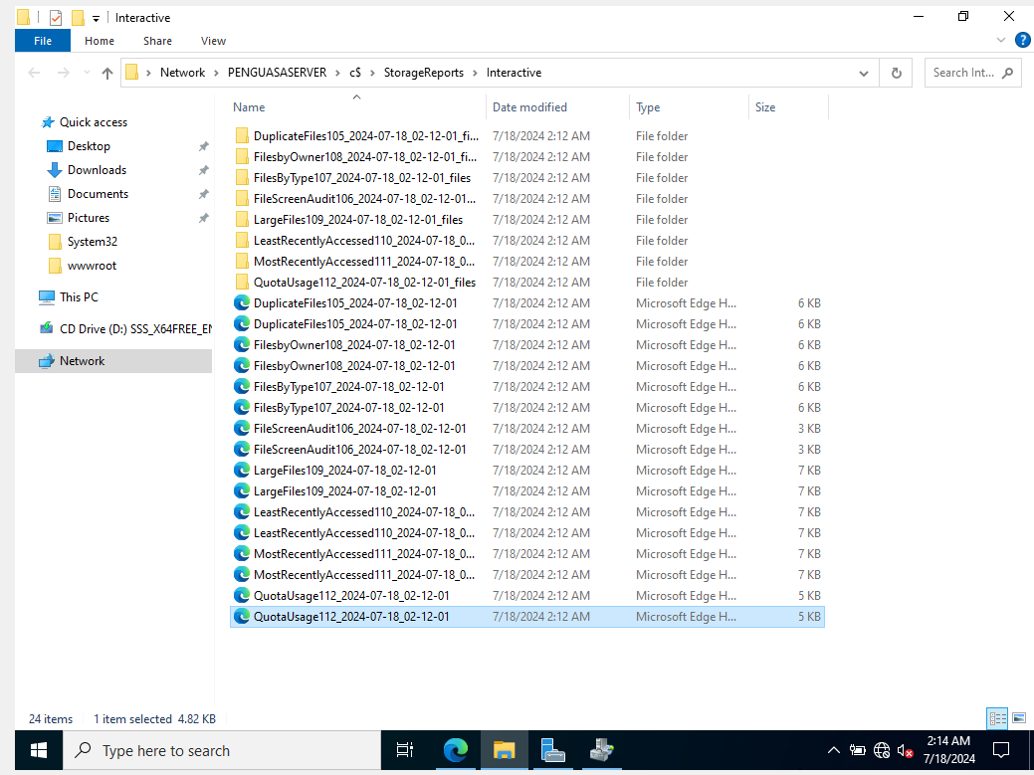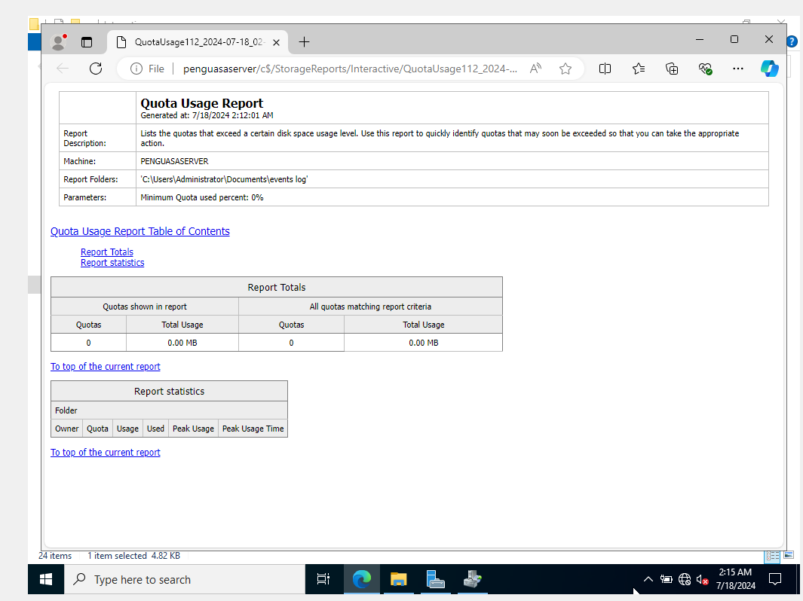

**Network Configuration**

ADRMS Configuration

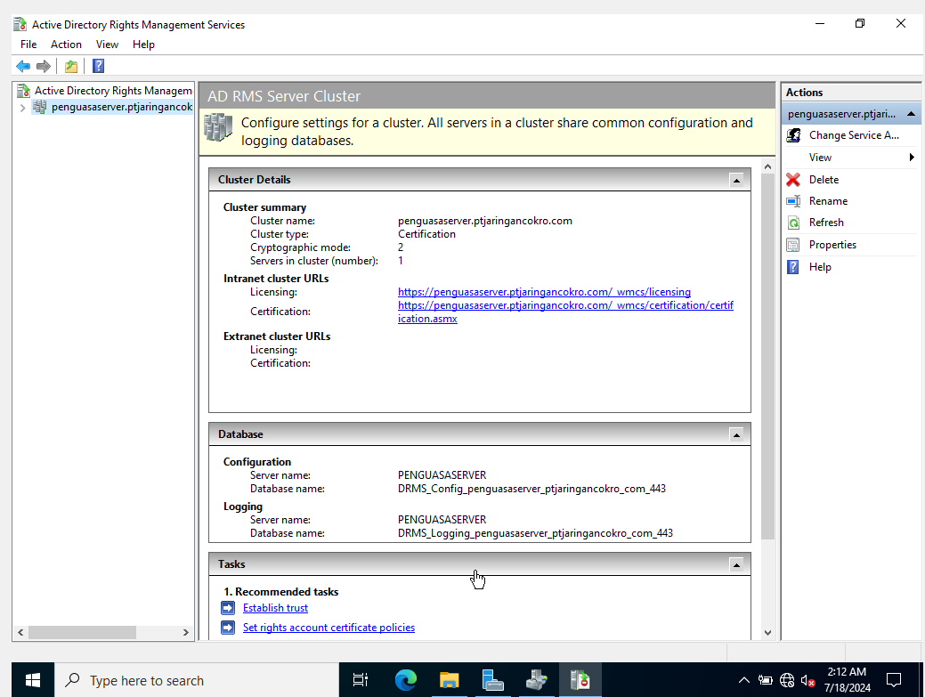

**Network Configuration**

Certificate Authorization

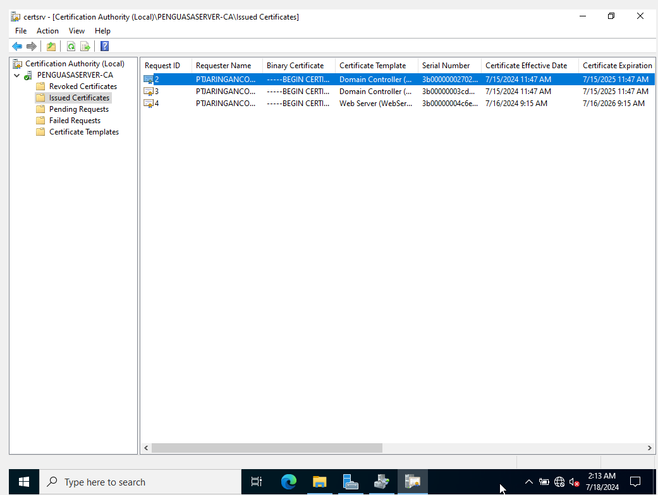

**Hardware:** Lenovo Ideapad Slim 3

**Software:** - OracleVM Virtual Box

**Operating System:** Windows Server 2022

**Configuration**